Name: - Sonam Abrol

Module 01 Lab

10-2-2019

1. Dashboard Screenshot DNS name:- bitnami-meanstack-6155-ip.centralus.cloudapp.azure.com

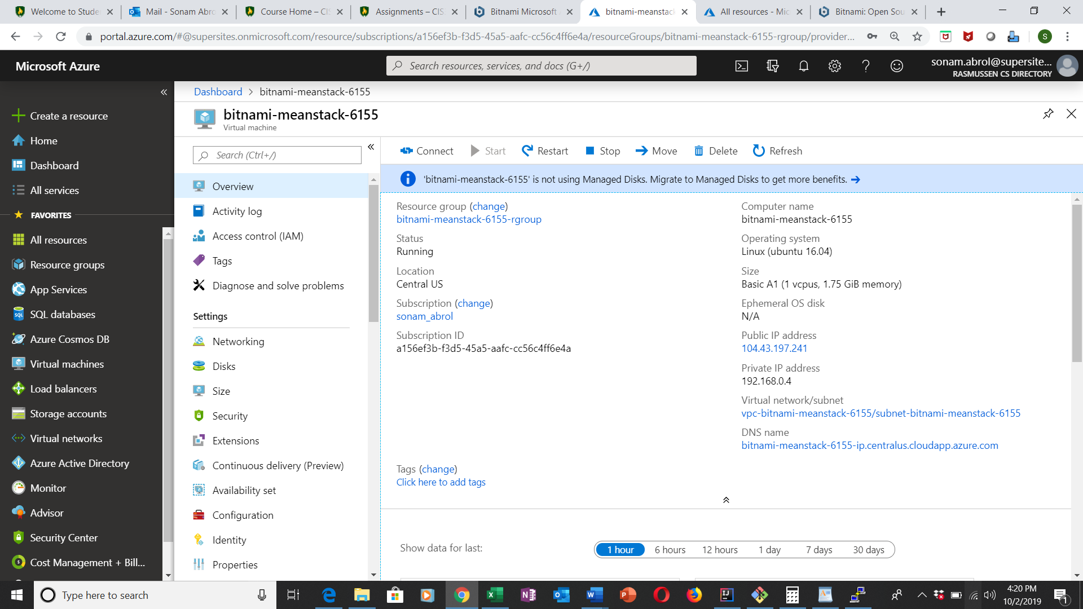

1. Congratulations page

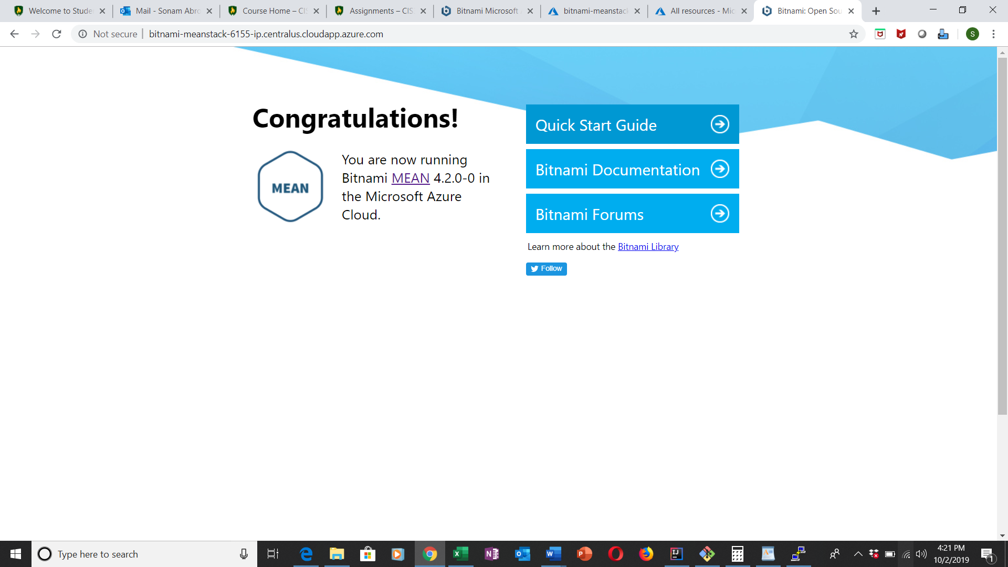

1. File Zilla

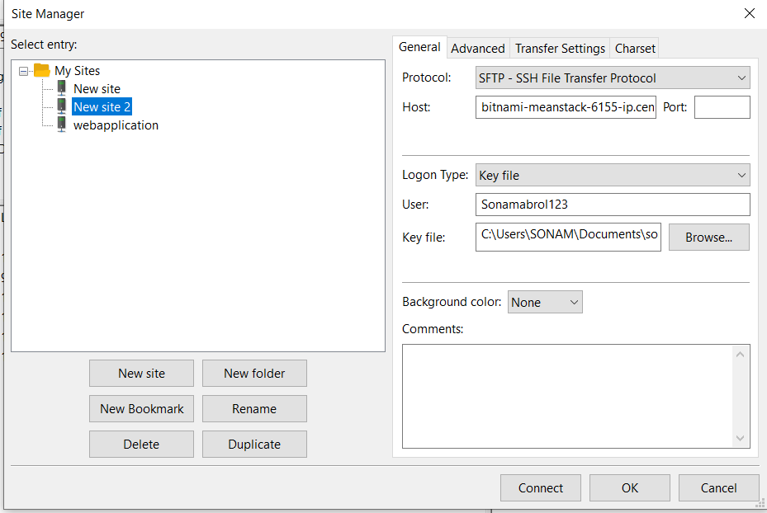

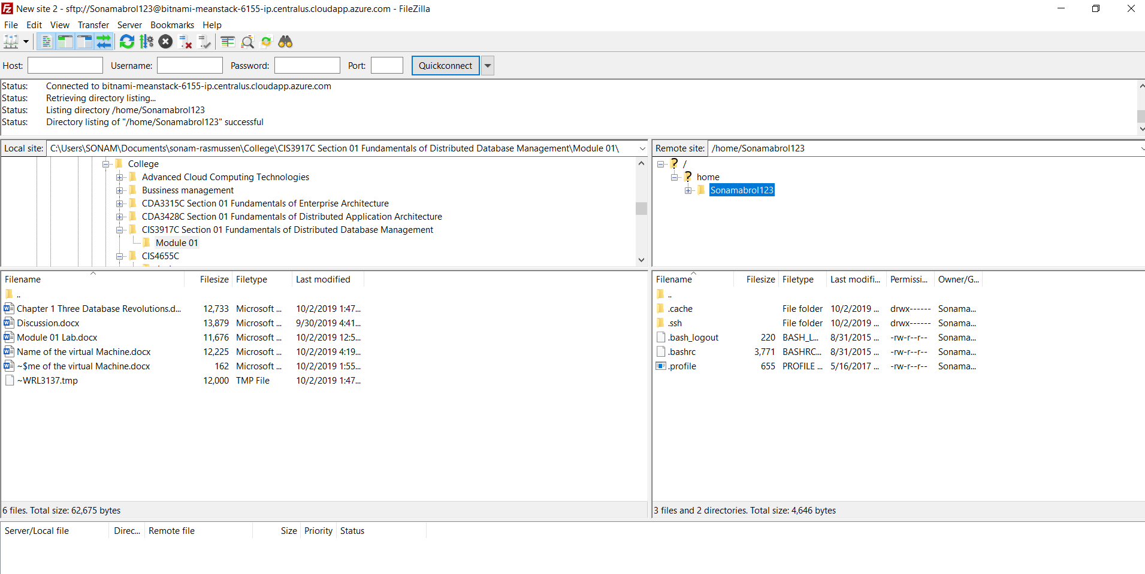

1. Putty

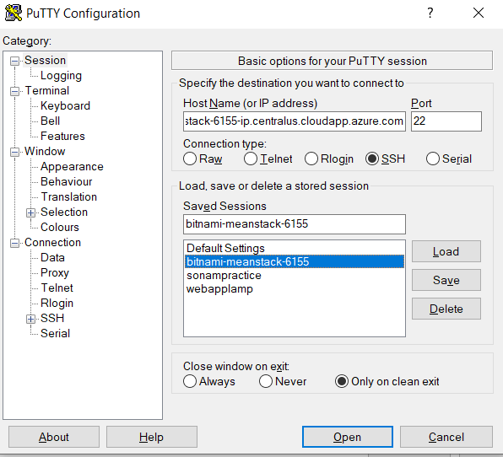

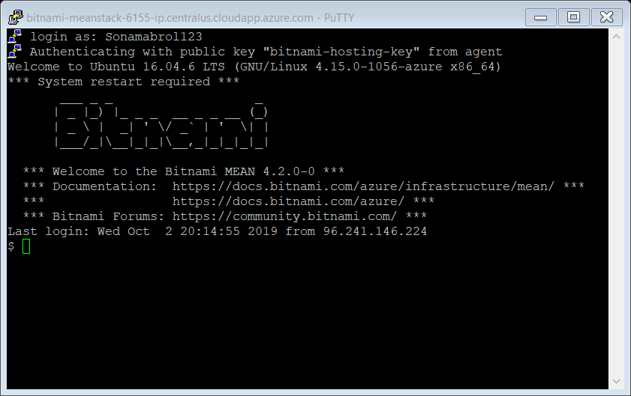

Screen Shot of git hub setup

